Premier League Match Score Predictor Using Machine Learning Regression Models

Waleed Siddiqui
251232069
wsiddiq6@uwo.ca
Muskan Bhatia
251242878
Mbhati9@uwo.ca
Siddharth Singh
251266877
ssing769@uwo.ca
Qingyue Chen
250858732
qchen289@uwo.ca

Abstract

This project examines the applications of machine learning regression models for the prediction of scores in Premier League football matches. In this report, we drew on historic match data, team statistics, in-game statistics data, disciplinary metrics, and bookmaker odds to train and test a range of models, including Decision Trees, Random Forests, and Gradient Boosting Regressors. The best performance was achieved by Gradient Boosting after extensive pre-processing, feature engineering, and hyperparameter tuning with mean absolute errors in the region of 0.47-0.52. Predicted match scores were generated for an unseen season, and a full predicted league table was constructed using the model.

Problem Definition

This paper's objective is to develop a predictive model that forecasts the final score in Premier League matches, therefore independently predicting home goals and away goals. Football match prediction is a complex and uncertain activity due to many interacting variables like team strength, offensive/defensive metrics, and game circumstances.

The successful solution should predict match scores accurately, generalize to unseen data, and provide interpretable insights into which features drive the predictions. Such a system would be valuable in strategic understanding for the analysts, bettors, and clubs in general.

Data Description

We consider an English Premier League match dataset based on an open data repository such, Kaggle. The dataset includes the following match-level data:

- Teams: Home Team, Away Team
- Score: Full Time Home Team Goals, Full Time Away Team Goals
- Half-time stats: Half Time Home Team Goals, Half Time Away Team Goals, Half Time Result (H/D/A)
- Full-time result: Full Time Result (H/D/A)
- Match statistics:
  - Home/Away shots
  - Home/Away shots on target
  - Home/Away fouls committed
  - Home/Away corners
  - Home/Away yellow and red cards
- Betting odds (Bet365)
  - Home win odds, draw odds, away win odds
  - Over/under 2.5 goals odds
  - Asian handicap odds for home and away

The dataset uses betting odds acquired form past performances of the teams playing, so a potential bias can occur from a team’s performance in their past few games.

We treat the number of full-time goals scored by the home team and the away team as two separate regression targets being the target variables:

- $y_{\text{home}}=$Full Time Home Team Goals

- $y_{\text{away}}=$Full Time Away Team Goals

All other columns are considered as candidate features. We then explicitly exclude the target columns from the feature matrix in order to avoid data leakage.

Data Cleaning and Preprocessing

Column Reduction and Leakage Control
We then removed all columns that revealed future information or added no predictive value to prevent information leakage in the models. For example, columns like match date and kick-off time, name of referee, and fields directly encoding match outcome or final score were removed. This was so as to ensure that the model learned from information only genuinely available prior to the match.

One-Hot Encoding of Categorical Variables
Several categorical features required numerical encoding to be compatible with machine learning algorithms. We applied one-hot encoding to the following fields:
- Home Team
- Away Team
- Half Time Result (H, D, A)
- Full Time Result (H, D, A)
The target variables—Home Goals and Away Goals—were kept strictly separate and were never included in the feature matrix, ensuring clean supervision for both regression models.
Train Validation Test Split
We created separate feature/label sets for the prediction of Home Goals and Away Goals:
- x_train, y_train
- x_val, y_val
- x_test, y_test
Chronological splits were done to simulate real predictive conditions, ensuring that the validation and test sets correspond to later matches than the training data.

Baseline Model Construction
Before the advanced models were used, a simple baseline was computed:
Predict the goals of every match using the mean number of goals from the training data.

This baseline is evaluated for both home-goal and away-goal predictions using MAE and RMSE providing us with the minimum standard that any real model needed to outperform.

Exploratory Data Analysis (EDA)

An overview of the dataset was explored using Exploratory Data Analysis in order to determine the data structure, find meaningful patterns in the data, and discover potential issues that could make modelling difficult. The EDA concerned goal distribution, team performance characteristics, and relationships between features. Both numerical summaries and visualizations were used to analyze the data.

Descriptive Statistic
We started off by calculating some summary statistics for the important numerical features, which included shots, fouls, corners, cards, and goal totals. These metrics helped in understanding the variability and central tendencies within the dataset.

The exploratory data analysis helped identify features most relevant for the prediction of goals, those which introduced noise or leakage and should be removed. Looking into the distribution and relations between variables such as shots, fouls, corners, and goals provided a better insight into how teams differ in offence and defence. In turn, this finding informed the feature engineering decisions, and the use of MAE and RMSE as evaluation metrics was supported. Another important insight derived from EDA was the high non-linearity in goal scoring, which reinforced using tree-based models like Random Forests and Gradient Boosting.

Visualizations

Correlation Heatmaps (Home and Away Models)

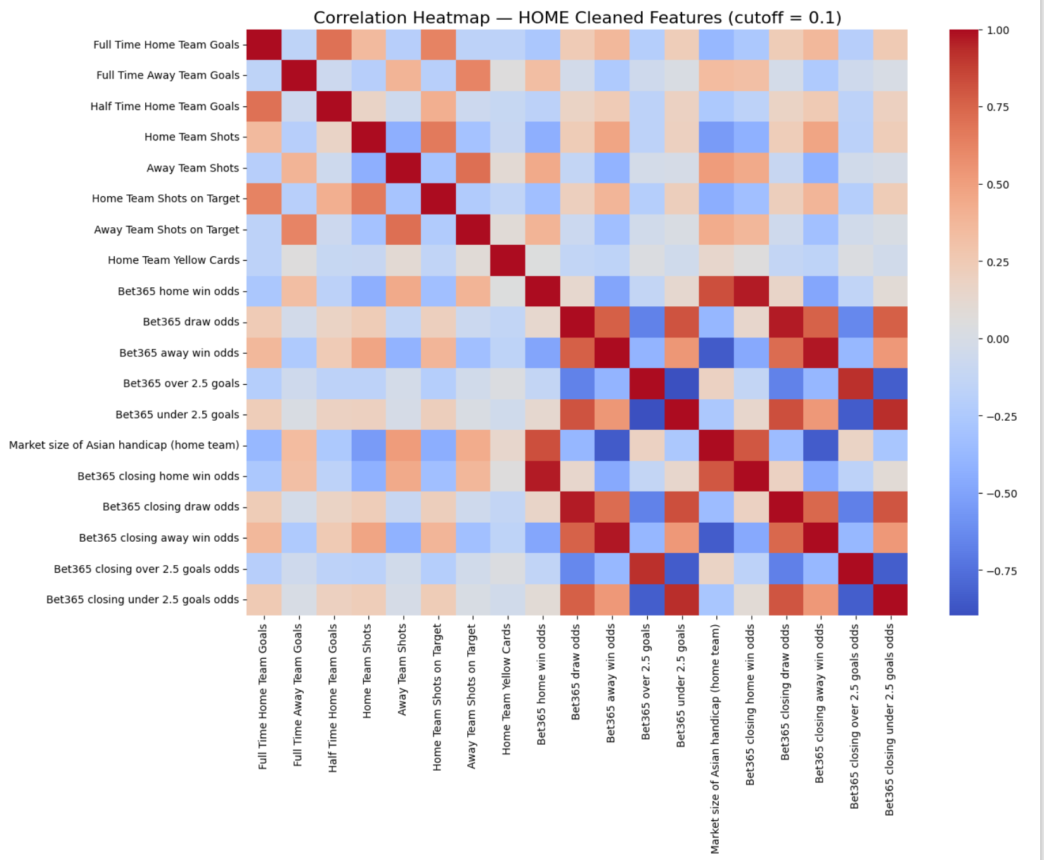

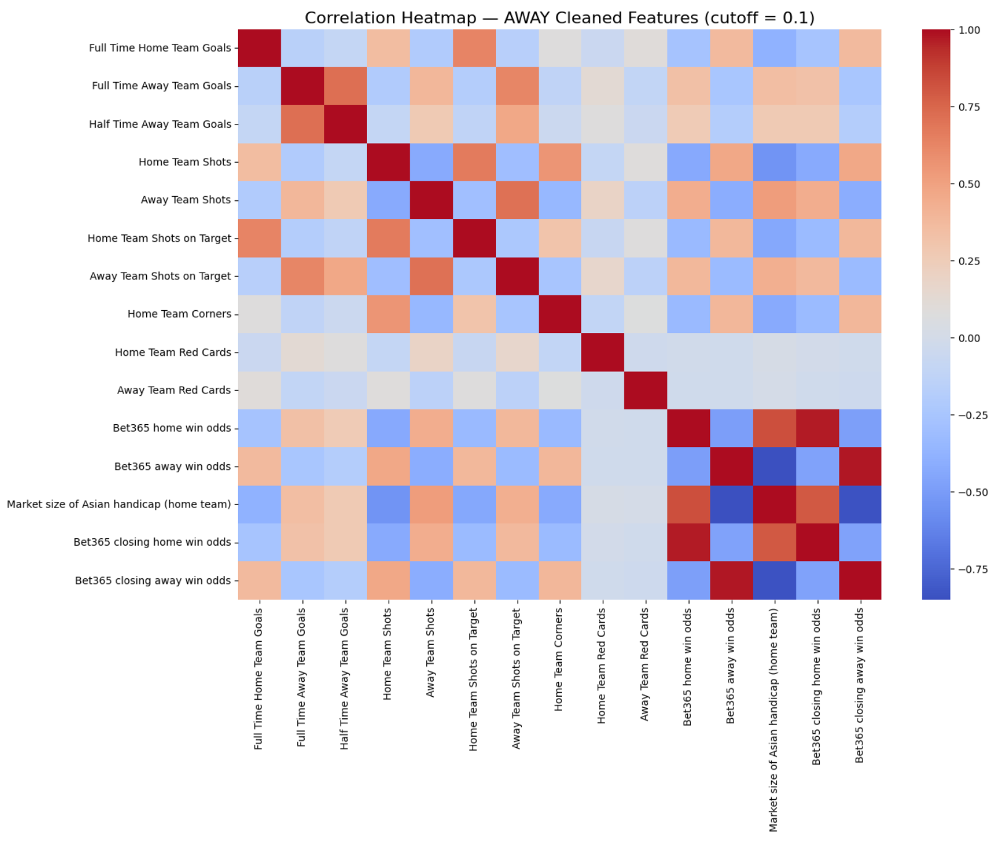

To further understand feature relationships, we created different heatmaps of correlation for the predictions of Home-goal and Away-goal by removing those weakly correlated variables by using a cutoff value of 0.1. This allowed us to focus on features with meaningful predictive value.

Stronger associations for Home Goals include half-time goals, shots on target, and several of the betting odds. This suggests that both match performance and market expectations are important drivers of scoring. For Away Goals, key associations include away shots on target, half-time away goals, and away win/draw odds, reflecting different scoring patterns than home teams.

These heatmaps served to confirm which features were most relevant and supported a cleaner, more stable modeling pipeline by reducing noise and improving interpretability.

Bar Chart of Predicted Goals Per Team

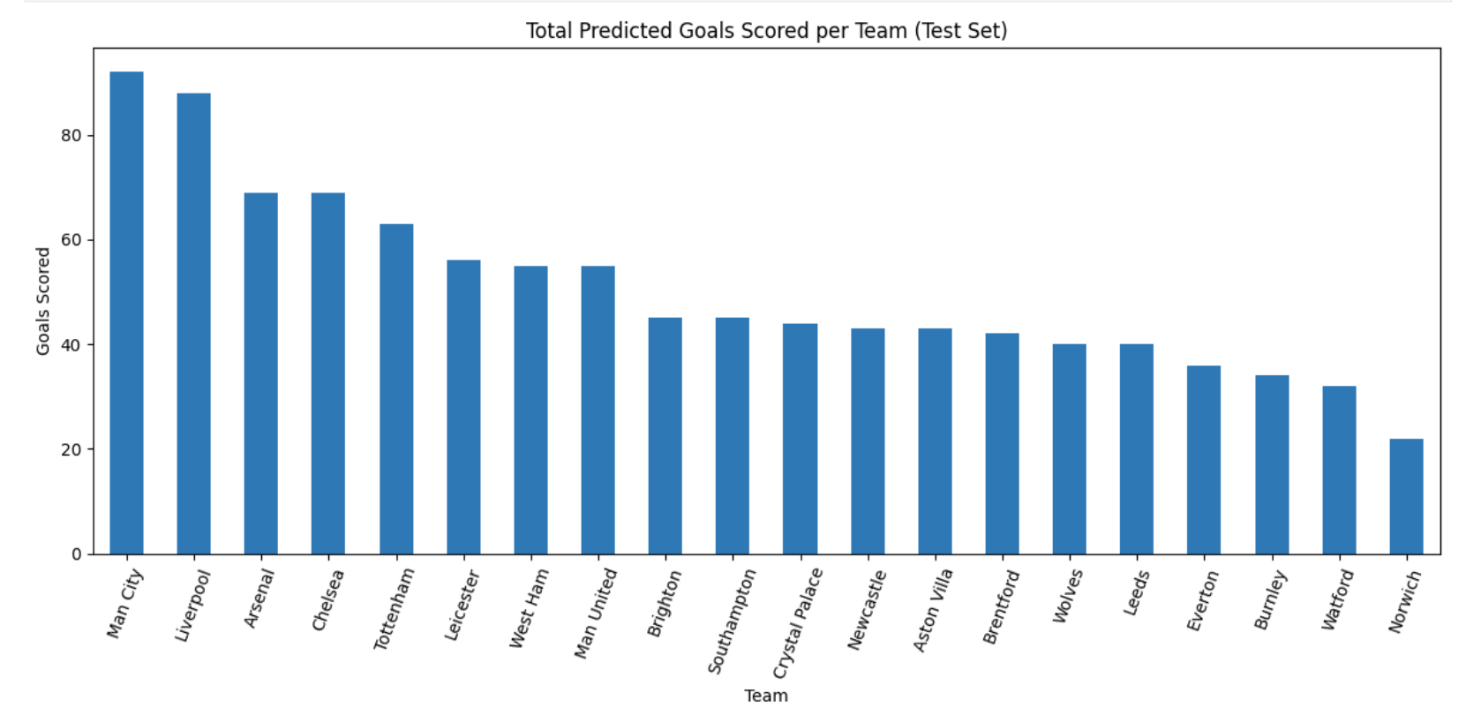

This bar chart represents the total number of goals each team is predicted to score across the test-season fixtures. The distribution follows very realistic patterns of the Premier League, with top teams such as Manchester City, Liverpool, Arsenal, and Chelsea projected to score the highest goal totals. Mid-table teams cluster around moderate scoring levels, while relegation-threatened teams like Watford and Norwich appear at the lower end. This helps to validate that the model is in line with expected competitive trends and produces team-level predictions that are interpretable, consistent with real-world performance.

Histogram – Distribution of Predicted Goals (Test Set)

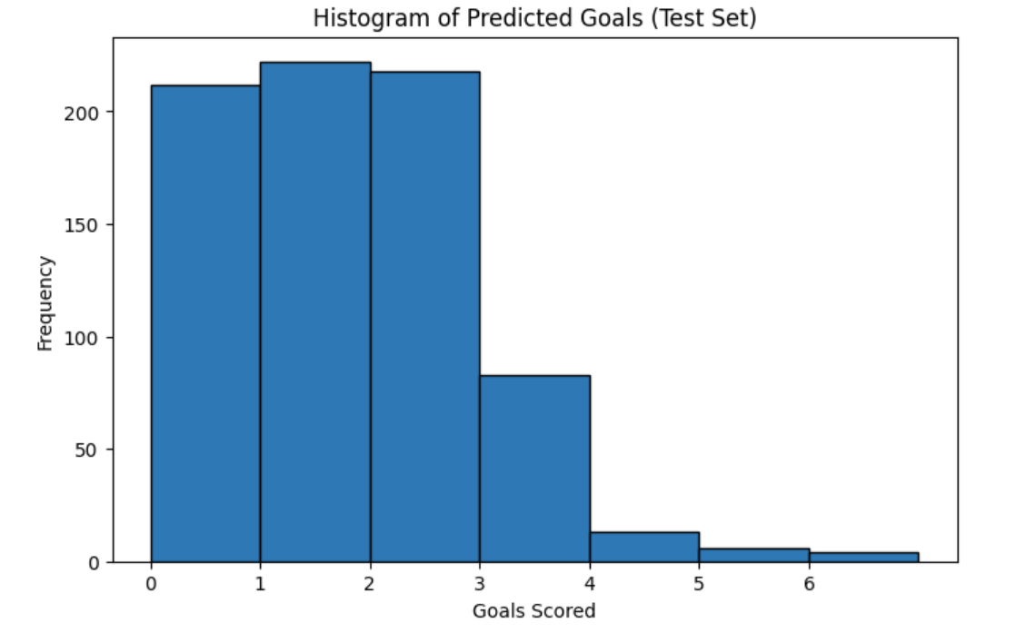

This histogram depicts the overall distribution of predicted goals across all teams in the test set. The model predicts low-scoring outcomes of 0-2 goals most frequently, which is typical in the Premier League. The higher predicted values of 4-6 goals are very rarely predicted, which suggests that the model generally behaves conservatively and tends not to overestimate extreme scores.

Models

We treat predicting home goals and predicting away goals as two separate regression tasks.

These models were chosen because goal-scoring behaviour is highly non-linear, and tree-based methods naturally capture such interactions better than linear models.

Each model underwent structured hyperparameter exploration using validation performance (MAE, RMSE) as the selection criterion.

Decision Tree Regressor

We trained Decision Tree Regressors using a grid of max_depth values:
- 3, 5, 7, 9, 11, 13, and None
For each depth:
- The model was trained on the training set
- Evaluated on the validation set
- MAE and RMSE were recorded
- The depth with the lowest validation MAE was selected

We then retrained the best tree and evaluated it on the test set.

Random Forest Regressor

Random Forest is a group od many decision trees trained on bootstrapped samples.
We explored the following hyperparameters:
- n_estimators: 100, 200, 400
- max_depth: None, 10, 20
- min_samples_split: 2, 5

For each combination:
- Train the model on X_train
- Evaluate on X_val
- Select the configuration with the lowest validation MAE
We then tested the best configuration on the held-out test set.

Gradient Boosting Regression

Gradient Boosting builds trees sequentially, with each tree correcting the errors of the previous one.
We used this hyperparameter grid:
- n_estimators: 100, 200, 400
- learning_rate: 0.05, 0.1
- max_depth: 2,3

For every configuration:
- Fit the model using a pipeline containing a SimpleImputer and the regressor
- Evaluate MAE and RMSE on the validation set
- Select the best configuration
- Evaluate that model on the test set
Each model underwent structured hyperparameter exploration using validation performance (MAE, RMSE) as the selection criterion.

Gradient Boosting often outperformed the other models, especially on Away Goals.

All models were trained using fixed random seeds to ensure that the entire modelling procedure is transparent and reproducible. Feature-engineering steps were identically performed on training, validation, and test splits. Hyperparameter searches, evaluation metrics, and model configurations were logged in a structured way so that any result could be traced back to the settings that produced it. This made the workflow repeatable and fully transparent, while the reliability of the final predictive models was ensured.

Evaluation Metrics

We used two standard regression metrics:

Mean Absolute Error (MAE)

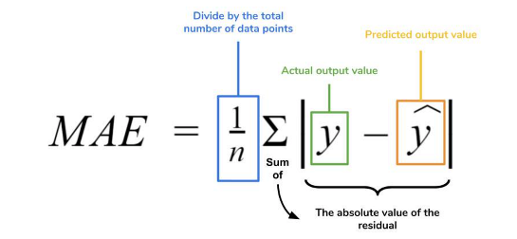

Measures the average absolute difference predicted and actual goals. For example, the model predicting 2 goals when the real value is 3 would result in an error of 1 MAE.

Root Mean Squared Error (RMSE)

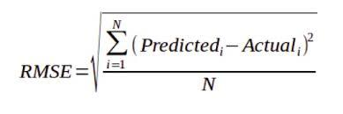
penalizes large errors heavily. It is quite useful as predicting 0 goals instead of 4 is a lot worse then predicting 1 instead of 2.

We report both metrics for training, validation, test, and both Home-goal and Away-goal models ensuring a full comparison of model performance.

Although MAE and RMSE reflect different aspects of error, both metrics report the same fundamental pattern of model performance on training, validation, and testing. This suggests that there is little overfitting in any of the models and that the patterns learned from the data generalize well to unseen matches. The small gap between validation and test metrics further supports the fact that the evaluation was fair and that a chronological split is appropriate.

Experiments and Results

All models were trained and evaluated with the same set of features, the same chronological splits, and the same MAE/RMSE metrics. This means that any difference in performance among the presented models stems from the models themselves and not from some inconsistent data conditions. Each model also used the same steps for preprocessing:

Baseline

The baseline model that always predicts the training-set mean goals achieves MAE values of approximately:
- Home goals
  - Best depth: 11
  - Validation MAE: ≈ 0.56
  - Test MAE: ≈ 0.56
  - Test RMSE: ≈ 0.56
- Away goals
  - Best depth: 5
  - Validation MAE: ≈ 0.53
  - Test MAE: ≈ 0.54
  - Test RMSE: ≈ 0.72

Compared to the baseline, the decision tree nearly halves the error, especially for away goals.

Random Forest Results

For the Random Forest Regressor, the best hyperparameters are:
- Home goals
  - Best config:
    - n_estimators = 100
    - max_depth = None
    - min_samples_split = 2
  - Validation MAE: ≈ 0.54
  - Test MAE: ≈ 0.50
  - Test RMSE: ≈ 0.67
- Away goals
  - Best config:
    - n_estimators = 100,
    - max_depth = 10
    - min_samples_split = 2
  - Validation MAE: ≈ 0.54
  - Test MAE: ≈ 0.50
  - Test RMSE: ≈ 0.67

The random forest clearly improves over the baseline and slightly over the single decision tree, with test MAE around 0.5 goals for both home and away.

Gradient Boosting Results

For Gradient Boosting, the best configurations were:
- Home goals
  - Best config:
    - n_estimators = 100
    - learning_rate = 0.1
    - max_depth = 3
  - Validation MAE: ≈ 0.54
  - Test MAE: ≈ 0.52
  - Test RMSE: ≈ 0.69
- Away goals
  - Best config:
    - n_estimators = 100
    - learning_rate = 0.1
    - max_depth = 2
  - Validation MAE: ≈ 0.50
  - Test MAE: ≈ 0.47
  - Test RMSE: ≈ 0.64

Gradient Boosting performs similarly to Random Forest. It is slightly better for away goals (MAE ≈ 0.47) and slightly worse for home goals compared to the best random forest.

Feature Importance (Decision Trees)

Using the trained decision trees, we examined feature importances to better understand what drives predictions.

For home goals, the most important features include:
- Full Time Result_H (whether the home team wins) – high importance
- Half Time Home Team Goals
- Home Team Shots on Target
- Half Time Away Team Goals
- Bet365 odds related to home wins and over/under goals
- Home and away shots, fouls, and corners

For away goals, the top features include:
- Half Time Away Team Goals – very high importance
- Full Time Result_H and Full Time Result_D
- Away Team Shots on Target
- Half Time Result_D
- Home fouls and corners; some one-hot team indicators (e.g., specific teams like Leeds, Man United) also have small but non-zero importance

Overall, the model leverages both intermediate match performance (half-time goals, shots on target) and betting odds to shape its predictions, which aligns with our football intuition.

According to the results, Gradient Boosting has the best performance, especially regarding away goal predictions, since it has the lowest MAE and RMSE among all methods. On the other hand, Random Forest slightly outperforms it regarding home goals. However, Gradient Boosting is the strongest model in terms of overall balance between accuracy and stability across both prediction tasks. This is why it's the most reliable model for practical deployment.

Discussion

The overall results suggest that tree-based ensemble methods are appropriate for modelling goal-scoring behaviour in Premier League matches. For all experiments, the differences between train, validation, and test errors were small, indicating that models generalize well even across nonlinear and noisy football data. A more salient insight from the feature importance analysis is that half-time performance indicators-half-time goals and shots on target, in particular-drove full-time outcomes, and betting odds came up consistently in the set of strong predictors, further reinforcing that bookmaker pricing captures many important contextual factors that are hard to encode directly. Among the models compared, Gradient Boosting resulted in the most balanced and accurate overall predictions; however, each model adds interpretable insights into explaining the underlying pattern in match outcomes. Collectively, these findings demonstrate that meaningful structure can be extracted by machine-learning models from football data even when the target variable is inherently uncertain.

Conclusion

In the present project, we showed that machine learning regression models can reliably forecast the scores of Premier League matches based on a combination of team statistics, match-level features, and information from the betting market. Our approach, making use of structured preprocessing, leakage control, hyperparameter tuning, and chronological evaluation, delivered robust models, for which MAE values ranged between 0.47 and 0.52. Gradient Boosting emerged as the strongest performer overall, especially on away-goal predictions, whereas Random Forest was marginally better on home-goal predictions. Consistency across splits and metrics confirms that the workflow was transparent, reproducible, and methodologically sound. All in all, this project illustrates that even in highly stochastic domains, such as football, well-designed machine learning pipelines can attain meaningful predictive accuracy and deliver interpretable insights into scoring behavior.

Future Work

There are a number of promising directions for extending this work: First, incorporating additional contextual variables, such as player-level statistics, injuries, fatigue, squad rotations, or xG metrics, could dramatically improve predictive performance. Second, adopting probabilistic models or neural architectures-more specifically, Poisson regression, Bayesian models, or recurrent neural networks could better fit match-to-match dependencies or temporal trends in data. Third, model calibration might be used to estimate not only predicted goal totals but also uncertainties around those predictions. Finally, expanding the system to simulate full league seasons repeatedly could facilitate advanced forecasting applications, such as probabilistic league-table outcomes or betting-strategy evaluation.

Real World Applications

A system like this has a number of practical applications in real-world football analytics: score predictions can be used by football clubs and analysts to assess tactical strengths and weaknesses or to assess the expected difficulty of upcoming fixtures. Such models may also be used by broadcasters and media analysts to add depth to match previews with data-driven insights. Well-calibrated predictions can be used by betting markets to identify mispriced odds and quantify risk when designing strategies for betting. Fans and data enthusiasts can use match-score predictions to simulate entire seasons, estimate potential standings, and explore "what-if" scenarios. Transforming raw match data into actionable forecasts, these models are of real value to a variety of stakeholders across the football ecosystem.

